2nd Grade Supply List 2024 - 2025
 | Quantity | Item
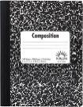 | 2 | Composition Books (speckled, not spiral)
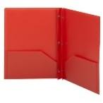 | 2 | Pronged Poly Plastic Folders (1 red, 1 blue)
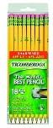 | 2 – 12 packs | #2 pencils, pre-sharpened (Ticonderoga brand, preferred)
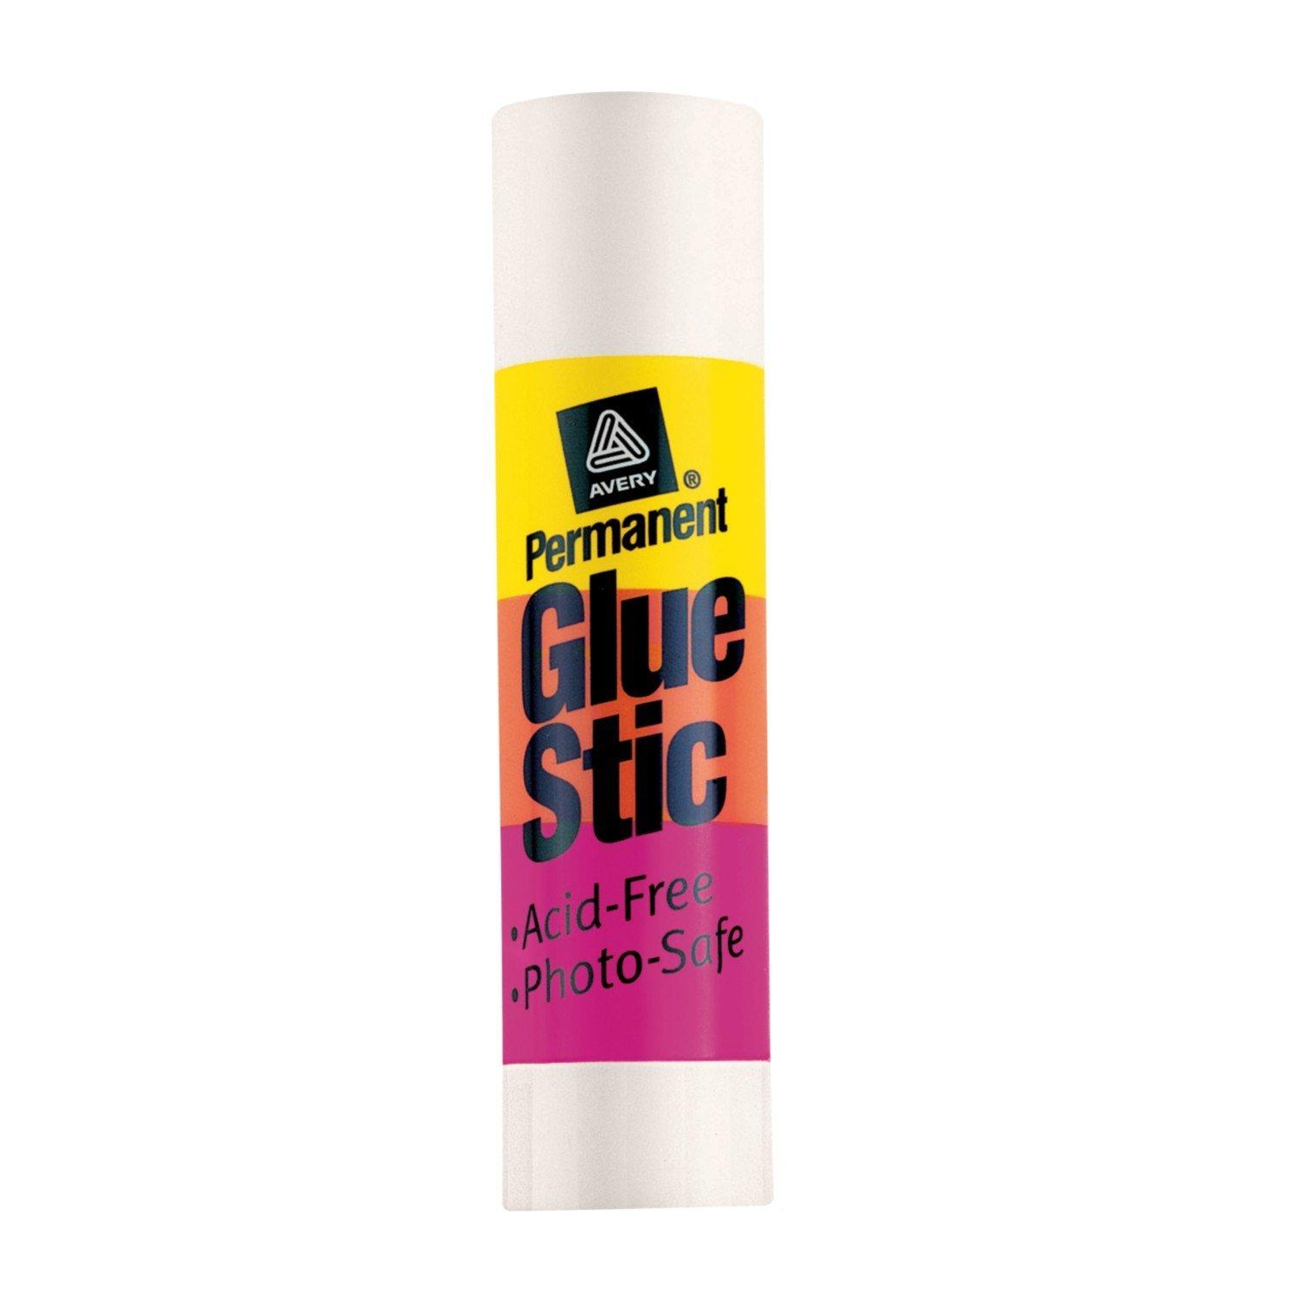 | 2 | Jumbo glue sticks
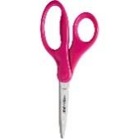 | 1 pairs | Child scissors
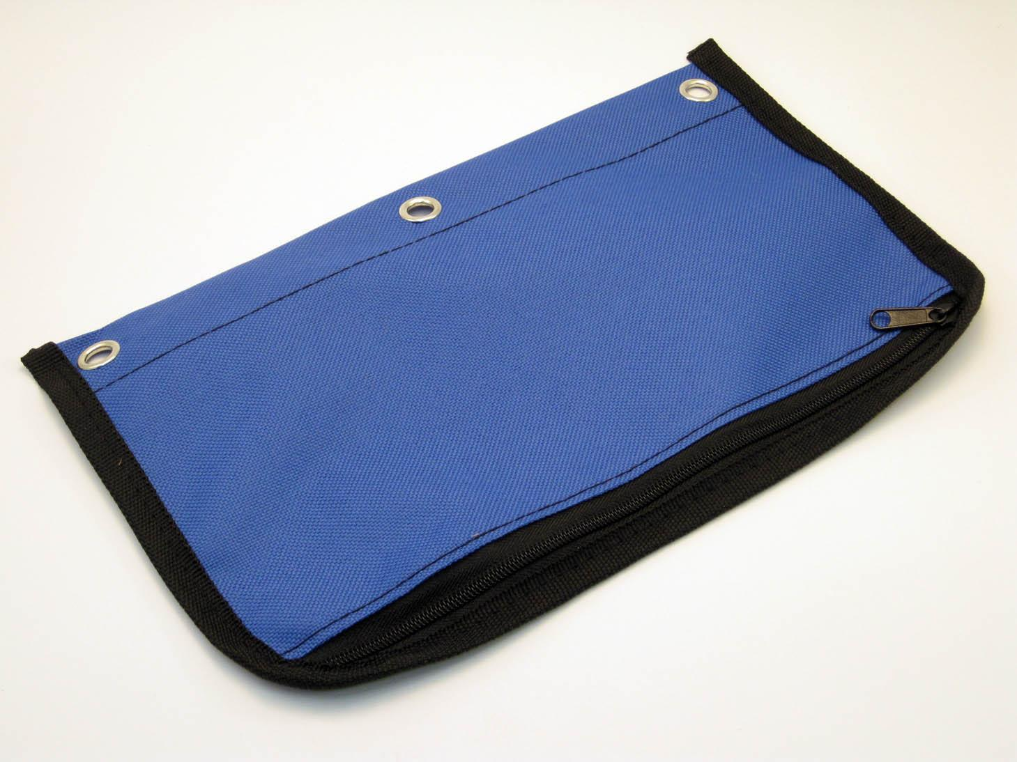 | 1 | Pencil pouch or box
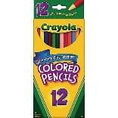 | 12 pack | Colored Pencils
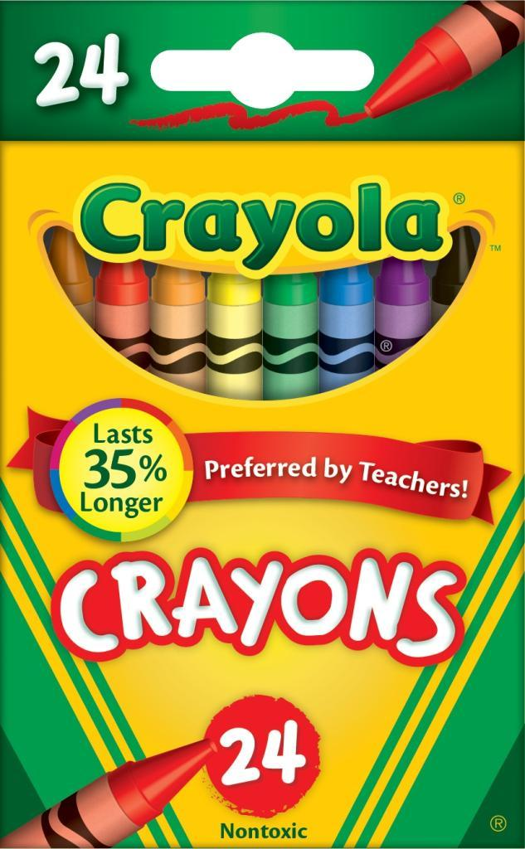 | 2 sets  24 pack | Crayons
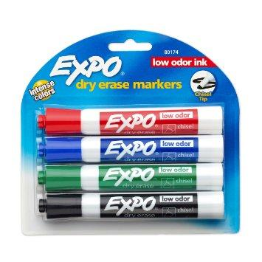 | 4 pack | Expo Dry Erase Markers - BLACK ONLY PLEASE
 | 1 set | Headphones
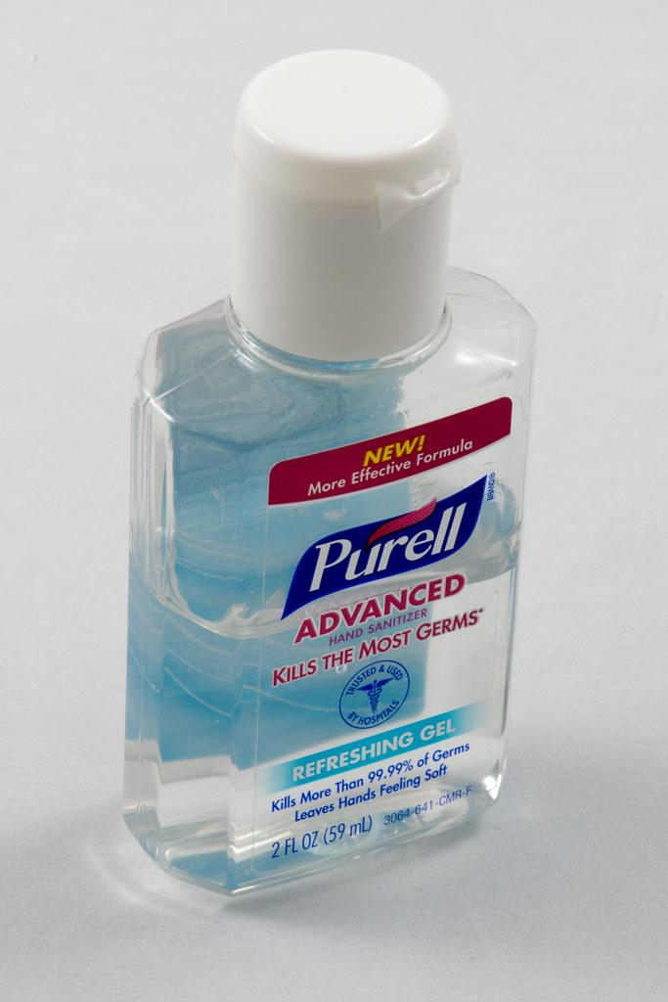 | 1 bottle | Hand Sanitizer
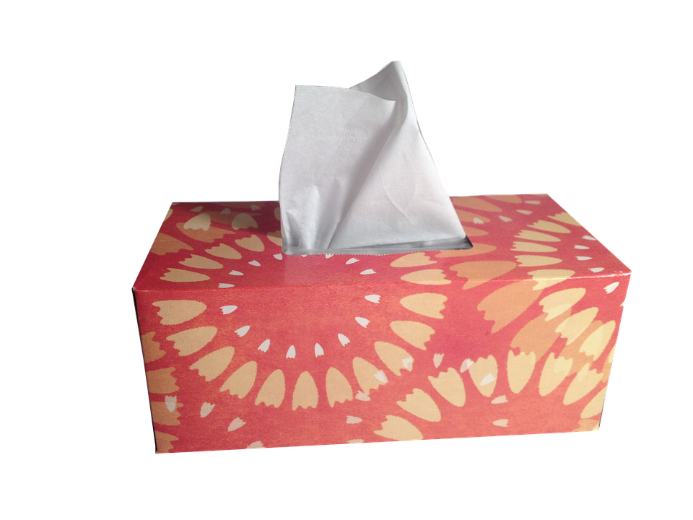 | 3 boxes | Tissues
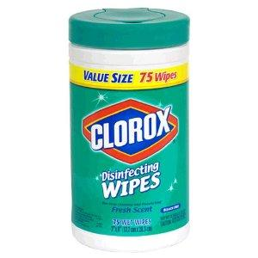 | 1 canister | Clorox Wipes
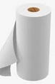 | 2 rolls | Paper towels

